1. Get me the IP address of a particular domain (guvi.in)

To get the Ip address we can use “nslookup” command in command prompt or terminal

Here when performed returned following result

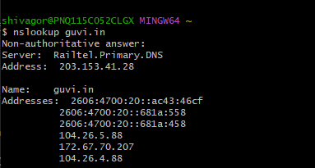

1. How do I find the CPU/memory usage of my server?

To view CPU/Memory Usage in Linux we use commands like ‘top’, ‘mpstat’ for CPU utilization

Top command returns following results

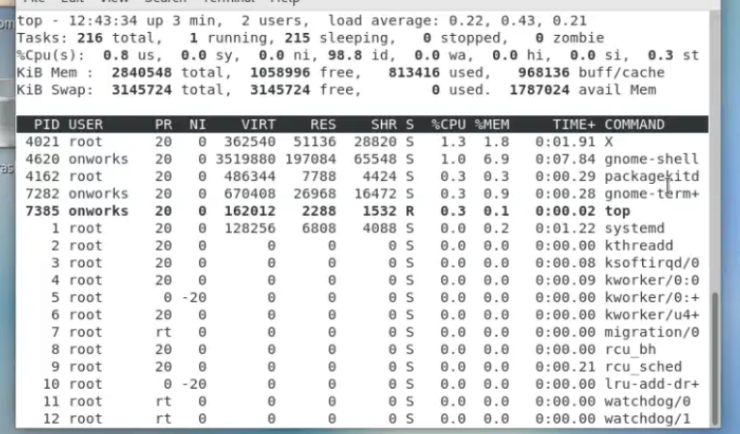

Mpstat returns following

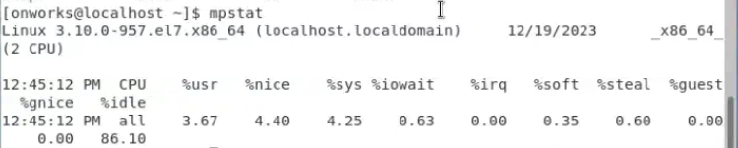

For memory utilization we can use free -h which returns following

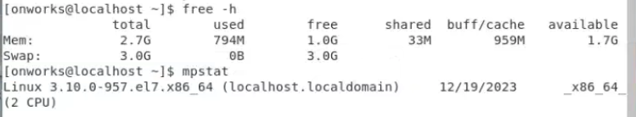

1. Test the connectivity between 2 nodes.

We can use ‘ping’ command to test connectivity between two nodes, here’s the following example

